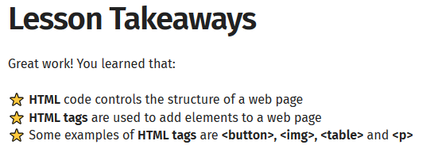





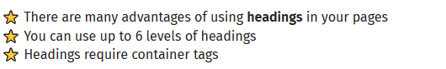

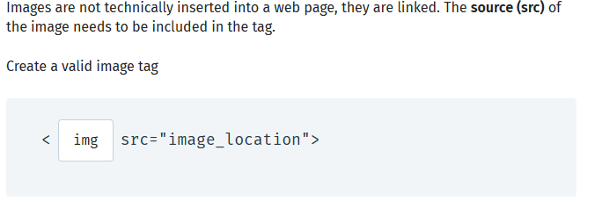

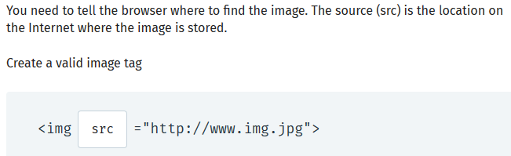

The **URL**is a location (or address) on the Web. The **image URL** needs to be enclosed in either single or double quotes.

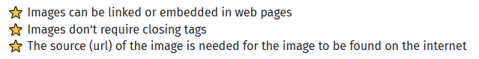

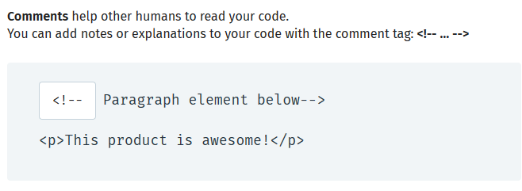

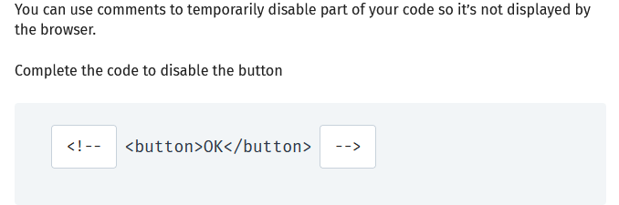

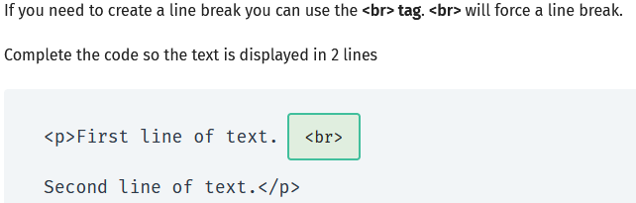

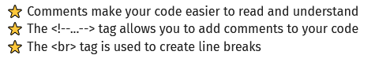

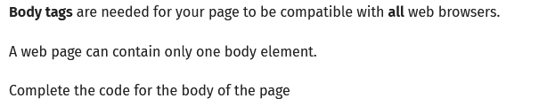

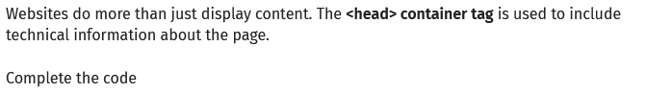





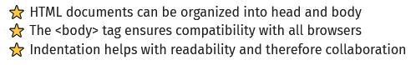

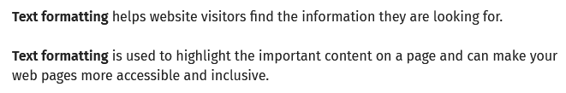

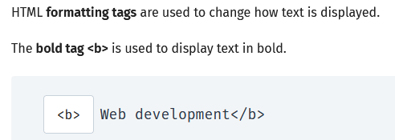

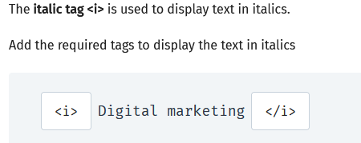

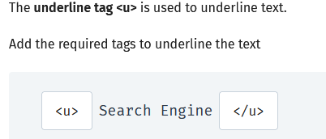

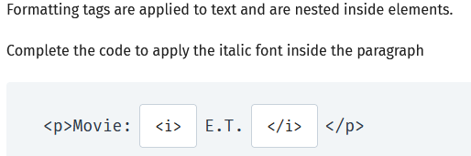

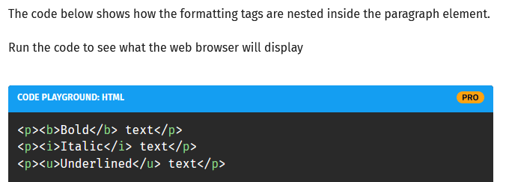

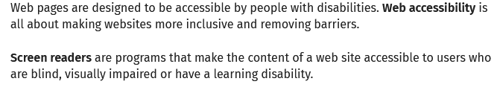

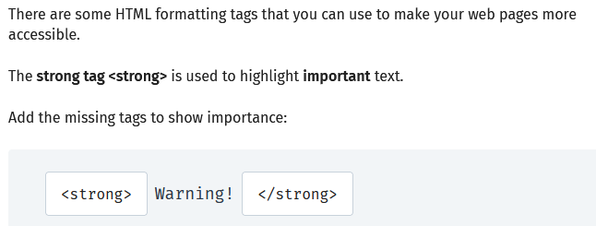

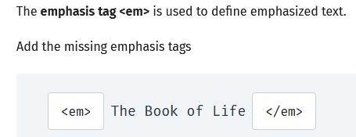

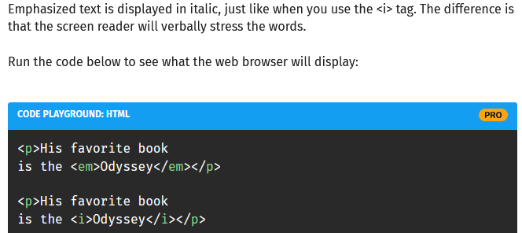

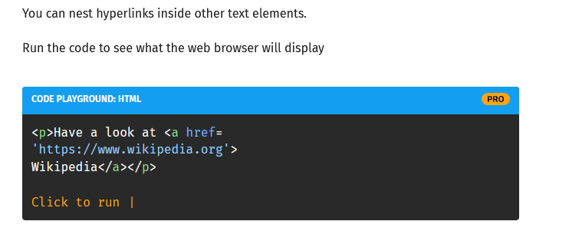

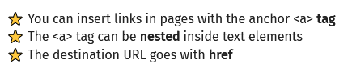

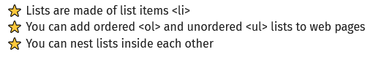

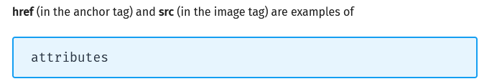

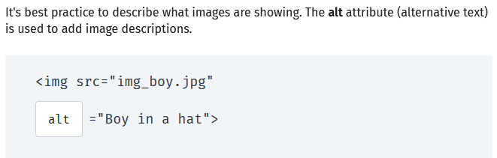

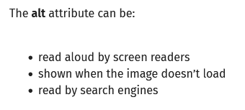

A Simple HTML Document

Example

<!DOCTYPE html>  
<html>  
<head>  
<title>Page Title</title>  
</head>  
<body>  
  
<h1>My First Heading</h1>  
<p>My first paragraph.</p>  
  
</body>  
</html>

### Example Explained

* The **<!DOCTYPE html>** declaration defines that this document is an HTML5 document
* The **<html>** element is the root element of an HTML page
* The **<head>** element contains meta information about the HTML page
* The **<title>** element specifies a title for the HTML page (which is shown in the browser's title bar or in the page's tab)
* The **<body>** element defines the document's body, and is a container for all the visible contents, such as headings, paragraphs, images, hyperlinks, tables, lists, etc.
* The **<h1>** element defines a large heading
* The **<p>** element defines a paragraph

**HTML links** are defined with the <a> tag: <a href="http://www.w3schools.com">This is a link</a>

## HTML Images. HTML images are defined with the <img> tag.

The source file (src), alternative text (alt), width, and height are provided as attributes:

### Example

<img src="w3schools.jpg" alt="W3Schools.com" width="104" height="142">

**An HTML element** is defined by a start tag, some content, and an end tag.

## HTML Elements

The HTML **element** is everything from the start tag to the end tag:

<tagname>Content goes here...</tagname>

Examples of some HTML elements:

<h1>My First Heading</h1>

<p>My first paragraph.</p>

|  |  |  |
| --- | --- | --- |
| **Start tag** | **Element content** | **End tag** |
| <h1> | My First Heading | </h1> |
| <p> | My first paragraph. | </p> |
| <br> | *none* | *none* |

Note: Some HTML elements have no content (like the <br> element). These elements are called empty elements. Empty elements do not have an end tag!

**HTML Attributes** HTML attributes provide additional information about HTML elements.

**HTML Attributes**

* All HTML elements can have attributes
* Attributes provide additional information about elements
* Attributes are always specified in the start tag
* Attributes usually come in name/value pairs like: name="value"

## Definition and Usage

* The <div> tag defines a division or a section in an HTML document.
* The <div> tag is used as a container for HTML elements - which is then styled with CSS or manipulated with JavaScript.
* The <div> tag is easily styled by using the class or
* id attribute.
* Any sort of content can be put inside the <div> tag!

**Note:** By default, browsers always place a line break before and after the <div> element.

## HTML Tags Ordered Alphabetically



|  |  |
| --- | --- |
| **Tag** | **Description** |
| [<!--...-->](https://www.w3schools.com/tags/tag_comment.asp) | Defines a comment |
| [<!DOCTYPE>](https://www.w3schools.com/tags/tag_doctype.asp) | Defines the document type |
| [<a>](https://www.w3schools.com/tags/tag_a.asp) | Defines a hyperlink |
| [<abbr>](https://www.w3schools.com/tags/tag_abbr.asp) | Defines an abbreviation or an acronym |
| [<acronym>](https://www.w3schools.com/tags/tag_acronym.asp) | Not supported in HTML5. Use [<abbr>](https://www.w3schools.com/tags/tag_abbr.asp) instead. Defines an acronym |
| [<address>](https://www.w3schools.com/tags/tag_address.asp) | Defines contact information for the author/owner of a document |
| [<applet>](https://www.w3schools.com/tags/tag_applet.asp) | Not supported in HTML5. Use [<embed>](https://www.w3schools.com/tags/tag_embed.asp) or [<object>](https://www.w3schools.com/tags/tag_object.asp) instead. Defines an embedded applet |
| [<area>](https://www.w3schools.com/tags/tag_area.asp) | Defines an area inside an image map |
| [<article>](https://www.w3schools.com/tags/tag_article.asp) | Defines an article |
| [<aside>](https://www.w3schools.com/tags/tag_aside.asp) | Defines content aside from the page content |
| [<audio>](https://www.w3schools.com/tags/tag_audio.asp) | Defines embedded sound content |
| [<b>](https://www.w3schools.com/tags/tag_b.asp) | Defines bold text |
| [<base>](https://www.w3schools.com/tags/tag_base.asp) | Specifies the base URL/target for all relative URLs in a document |
| [<basefont>](https://www.w3schools.com/tags/tag_basefont.asp) | Not supported in HTML5. Use CSS instead. Specifies a default color, size, and font for all text in a document |
| [<bdi>](https://www.w3schools.com/tags/tag_bdi.asp) | Isolates a part of text that might be formatted in a different direction from other text outside it |
| [<bdo>](https://www.w3schools.com/tags/tag_bdo.asp) | Overrides the current text direction |
| [<big>](https://www.w3schools.com/tags/tag_big.asp) | Not supported in HTML5. Use CSS instead. Defines big text |
| [<blockquote>](https://www.w3schools.com/tags/tag_blockquote.asp) | Defines a section that is quoted from another source |
| [<body>](https://www.w3schools.com/tags/tag_body.asp) | Defines the document's body |
| [<br>](https://www.w3schools.com/tags/tag_br.asp) | Defines a single line break |
| [<button>](https://www.w3schools.com/tags/tag_button.asp) | Defines a clickable button |
| [<canvas>](https://www.w3schools.com/tags/tag_canvas.asp) | Used to draw graphics, on the fly, via scripting (usually JavaScript) |
| [<caption>](https://www.w3schools.com/tags/tag_caption.asp) | Defines a table caption |
| [<center>](https://www.w3schools.com/tags/tag_center.asp) | Not supported in HTML5. Use CSS instead. Defines centered text |
| [<cite>](https://www.w3schools.com/tags/tag_cite.asp) | Defines the title of a work |
| [<code>](https://www.w3schools.com/tags/tag_code.asp) | Defines a piece of computer code |
| [<col>](https://www.w3schools.com/tags/tag_col.asp) | Specifies column properties for each column within a <colgroup> element |
| [<colgroup>](https://www.w3schools.com/tags/tag_colgroup.asp) | Specifies a group of one or more columns in a table for formatting |
| [<data>](https://www.w3schools.com/tags/tag_data.asp) | Adds a machine-readable translation of a given content |
| [<datalist>](https://www.w3schools.com/tags/tag_datalist.asp) | Specifies a list of pre-defined options for input controls |
| [<dd>](https://www.w3schools.com/tags/tag_dd.asp) | Defines a description/value of a term in a description list |
| [<del>](https://www.w3schools.com/tags/tag_del.asp) | Defines text that has been deleted from a document |
| [<details>](https://www.w3schools.com/tags/tag_details.asp) | Defines additional details that the user can view or hide |
| [<dfn>](https://www.w3schools.com/tags/tag_dfn.asp) | Specifies a term that is going to be defined within the content |
| [<dialog>](https://www.w3schools.com/tags/tag_dialog.asp) | Defines a dialog box or window |
| [<dir>](https://www.w3schools.com/tags/tag_dir.asp) | Not supported in HTML5. Use [<ul>](https://www.w3schools.com/tags/tag_ul.asp) instead. Defines a directory list |
| [<div>](https://www.w3schools.com/tags/tag_div.asp) | Defines a section in a document |
| [<dl>](https://www.w3schools.com/tags/tag_dl.asp) | Defines a description list |
| [<dt>](https://www.w3schools.com/tags/tag_dt.asp) | Defines a term/name in a description list |
| [<em>](https://www.w3schools.com/tags/tag_em.asp) | Defines emphasized text |
| [<embed>](https://www.w3schools.com/tags/tag_embed.asp) | Defines a container for an external application |
| [<fieldset>](https://www.w3schools.com/tags/tag_fieldset.asp) | Groups related elements in a form |
| [<figcaption>](https://www.w3schools.com/tags/tag_figcaption.asp) | Defines a caption for a <figure> element |
| [<figure>](https://www.w3schools.com/tags/tag_figure.asp) | Specifies self-contained content |
| [<font>](https://www.w3schools.com/tags/tag_font.asp) | Not supported in HTML5. Use CSS instead. Defines font, color, and size for text |
| [<footer>](https://www.w3schools.com/tags/tag_footer.asp) | Defines a footer for a document or section |
| [<form>](https://www.w3schools.com/tags/tag_form.asp) | Defines an HTML form for user input |
| [<frame>](https://www.w3schools.com/tags/tag_frame.asp) | Not supported in HTML5. Defines a window (a frame) in a frameset |
| [<frameset>](https://www.w3schools.com/tags/tag_frameset.asp) | Not supported in HTML5. Defines a set of frames |
| [<h1> to <h6>](https://www.w3schools.com/tags/tag_hn.asp) | Defines HTML headings |
| [<head>](https://www.w3schools.com/tags/tag_head.asp) | Contains metadata/information for the document |
| [<header>](https://www.w3schools.com/tags/tag_header.asp) | Defines a header for a document or section |
| [<hr>](https://www.w3schools.com/tags/tag_hr.asp) | Defines a thematic change in the content |
| [<html>](https://www.w3schools.com/tags/tag_html.asp) | Defines the root of an HTML document |
| [<i>](https://www.w3schools.com/tags/tag_i.asp) | Defines a part of text in an alternate voice or mood |
| [<iframe>](https://www.w3schools.com/tags/tag_iframe.asp) | Defines an inline frame |
| [<img>](https://www.w3schools.com/tags/tag_img.asp) | Defines an image |
| [<input>](https://www.w3schools.com/tags/tag_input.asp) | Defines an input control |
| [<ins>](https://www.w3schools.com/tags/tag_ins.asp) | Defines a text that has been inserted into a document |
| [<kbd>](https://www.w3schools.com/tags/tag_kbd.asp) | Defines keyboard input |
| [<label>](https://www.w3schools.com/tags/tag_label.asp) | Defines a label for an <input> element |
| [<legend>](https://www.w3schools.com/tags/tag_legend.asp) | Defines a caption for a <fieldset> element |
| [<li>](https://www.w3schools.com/tags/tag_li.asp) | Defines a list item |
| [<link>](https://www.w3schools.com/tags/tag_link.asp) | Defines the relationship between a document and an external resource (most used to link to style sheets) |
| [<main>](https://www.w3schools.com/tags/tag_main.asp) | Specifies the main content of a document |
| [<map>](https://www.w3schools.com/tags/tag_map.asp) | Defines an image map |
| [<mark>](https://www.w3schools.com/tags/tag_mark.asp) | Defines marked/highlighted text |
| [<meta>](https://www.w3schools.com/tags/tag_meta.asp) | Defines metadata about an HTML document |
| [<meter>](https://www.w3schools.com/tags/tag_meter.asp) | Defines a scalar measurement within a known range (a gauge) |
| [<nav>](https://www.w3schools.com/tags/tag_nav.asp) | Defines navigation links |
| [<noframes>](https://www.w3schools.com/tags/tag_noframes.asp) | Not supported in HTML5. Defines an alternate content for users that do not support frames |
| [<noscript>](https://www.w3schools.com/tags/tag_noscript.asp) | Defines an alternate content for users that do not support client-side scripts |
| [<object>](https://www.w3schools.com/tags/tag_object.asp) | Defines a container for an external application |
| [<ol>](https://www.w3schools.com/tags/tag_ol.asp) | Defines an ordered list |
| [<optgroup>](https://www.w3schools.com/tags/tag_optgroup.asp) | Defines a group of related options in a drop-down list |
| [<option>](https://www.w3schools.com/tags/tag_option.asp) | Defines an option in a drop-down list |
| [<output>](https://www.w3schools.com/tags/tag_output.asp) | Defines the result of a calculation |
| [<p>](https://www.w3schools.com/tags/tag_p.asp) | Defines a paragraph |
| [<param>](https://www.w3schools.com/tags/tag_param.asp) | Defines a parameter for an object |
| [<picture>](https://www.w3schools.com/tags/tag_picture.asp) | Defines a container for multiple image resources |
| [<pre>](https://www.w3schools.com/tags/tag_pre.asp) | Defines preformatted text |
| [<progress>](https://www.w3schools.com/tags/tag_progress.asp) | Represents the progress of a task |
| [<q>](https://www.w3schools.com/tags/tag_q.asp) | Defines a short quotation |
| [<rp>](https://www.w3schools.com/tags/tag_rp.asp) | Defines what to show in browsers that do not support ruby annotations |
| [<rt>](https://www.w3schools.com/tags/tag_rt.asp) | Defines an explanation/pronunciation of characters (for East Asian typography) |
| [<ruby>](https://www.w3schools.com/tags/tag_ruby.asp) | Defines a ruby annotation (for East Asian typography) |
| [<s>](https://www.w3schools.com/tags/tag_s.asp) | Defines text that is no longer correct |
| [<samp>](https://www.w3schools.com/tags/tag_samp.asp) | Defines sample output from a computer program |
| [<script>](https://www.w3schools.com/tags/tag_script.asp) | Defines a client-side script |
| [<section>](https://www.w3schools.com/tags/tag_section.asp) | Defines a section in a document |
| [<select>](https://www.w3schools.com/tags/tag_select.asp) | Defines a drop-down list |
| [<small>](https://www.w3schools.com/tags/tag_small.asp) | Defines smaller text |
| [<source>](https://www.w3schools.com/tags/tag_source.asp) | Defines multiple media resources for media elements (<video> and <audio>) |
| [<span>](https://www.w3schools.com/tags/tag_span.asp) | Defines a section in a document |
| [<strike>](https://www.w3schools.com/tags/tag_strike.asp) | Not supported in HTML5. Use [<del>](https://www.w3schools.com/tags/tag_del.asp) or [<s>](https://www.w3schools.com/tags/tag_s.asp) instead. Defines strikethrough text |
| [<strong>](https://www.w3schools.com/tags/tag_strong.asp) | Defines important text |
| [<style>](https://www.w3schools.com/tags/tag_style.asp) | Defines style information for a document |
| [<sub>](https://www.w3schools.com/tags/tag_sub.asp) | Defines subscripted text |
| [<summary>](https://www.w3schools.com/tags/tag_summary.asp) | Defines a visible heading for a <details> element |
| [<sup>](https://www.w3schools.com/tags/tag_sup.asp) | Defines superscripted text |
| [<svg>](https://www.w3schools.com/tags/tag_svg.asp) | Defines a container for SVG graphics |
| [<table>](https://www.w3schools.com/tags/tag_table.asp) | Defines a table |
| [<tbody>](https://www.w3schools.com/tags/tag_tbody.asp) | Groups the body content in a table |
| [<td>](https://www.w3schools.com/tags/tag_td.asp) | Defines a cell in a table |
| [<template>](https://www.w3schools.com/tags/tag_template.asp) | Defines a container for content that should be hidden when the page loads |
| [<textarea>](https://www.w3schools.com/tags/tag_textarea.asp) | Defines a multiline input control (text area) |
| [<tfoot>](https://www.w3schools.com/tags/tag_tfoot.asp) | Groups the footer content in a table |
| [<th>](https://www.w3schools.com/tags/tag_th.asp) | Defines a header cell in a table |
| [<thead>](https://www.w3schools.com/tags/tag_thead.asp) | Groups the header content in a table |
| [<time>](https://www.w3schools.com/tags/tag_time.asp) | Defines a specific time (or datetime) |
| [<title>](https://www.w3schools.com/tags/tag_title.asp) | Defines a title for the document |
| [<tr>](https://www.w3schools.com/tags/tag_tr.asp) | Defines a row in a table |
| [<track>](https://www.w3schools.com/tags/tag_track.asp) | Defines text tracks for media elements (<video> and <audio>) |
| [<tt>](https://www.w3schools.com/tags/tag_tt.asp) | Not supported in HTML5. Use CSS instead. Defines teletype text |
| [<u>](https://www.w3schools.com/tags/tag_u.asp) | Defines some text that is unarticulated and styled differently from normal text |
| [<ul>](https://www.w3schools.com/tags/tag_ul.asp) | Defines an unordered list |
| [<var>](https://www.w3schools.com/tags/tag_var.asp) | Defines a variable |
| [<video>](https://www.w3schools.com/tags/tag_video.asp) | Defines embedded video content |
| [<wbr>](https://www.w3schools.com/tags/tag_wbr.asp) | Defines a possible line-break |

**Layout**

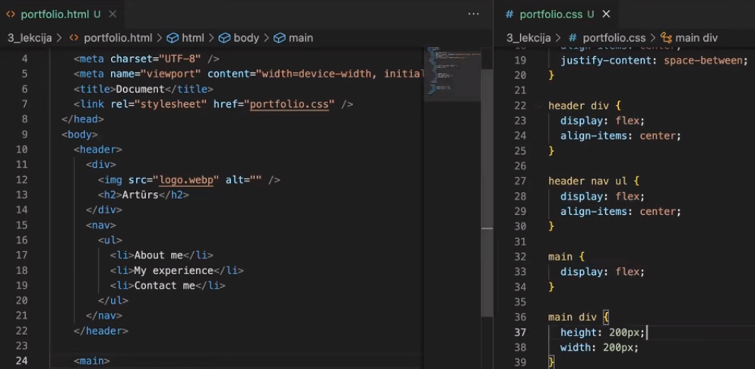

**Backgraund ievietošana lapā. Kodu raksts css failā.**

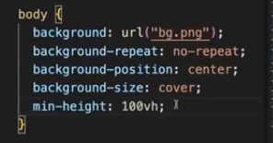

Bildes aizvietošana sadaļā kā bacgraund. HTLM fails -> <div class=”red”></div> izdzēš bildi ( scr)

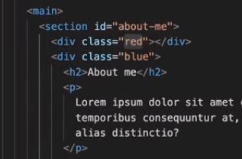

Css fails-> ievieto iepriekšējo bildi kā backgraund.

